
Koneru Lakshmaiah Education Foundation
(Deemed to be University estd. u/s. 3 of the UGC Act, 1956)
Off-Campus: Bachupally-Gandimaisamma Road, Bowrampet, Hyderabad, Telangana - 500 043. Phone No: 7815926816, www.klh.edu.in

STUDENT CASE STUDY EXECUTION REPORT
Department | FED
Subject | DSA-2
Academic Year | 1-111 Semester | 2025-26
Faculty Name | Ms. P.Surekha
Student Name | M.Sreeya
Roll Number | 2500032243
Branch | CSE
Course Outcome | 12SC1305E
Case Study Topic: Network Traffic Spike Detection System
Work Done Summary:
In this case study, I implemented a Segment Tree–based network traffic monitoring system for efficient traffic spike detection and cyber attack analysis.
The Segment Tree structure was used to analyze packet traffic across different time intervals for faster range-based traffic monitoring. I analyzed multiple hourly traffic records and identified abnormal traffic spikes indicating possible DDoS attack patterns.
I also implemented traffic interval analysis, packet surge detection, and automated traffic status reporting to improve real-time cybersecurity monitoring efficiency.
Implementation Details:

1. Stored hourly network traffic records for traffic analysis.

2. Constructed Segment Tree for efficient range query operations.
3. Implemented range-based packet traffic calculation using Segment Tree queries.
4. Analyzed network traffic between specific time intervals.

5. Detected abnormal traffic spikes indicating possible DDoS attacks.

6. Implemented automated traffic status monitoring and alert generation.
7. Concluded Segment Tree is efficient for scalable real-time traffic analysis because range query operations are performed in O(log n) time.

Result: Screenshots / Output
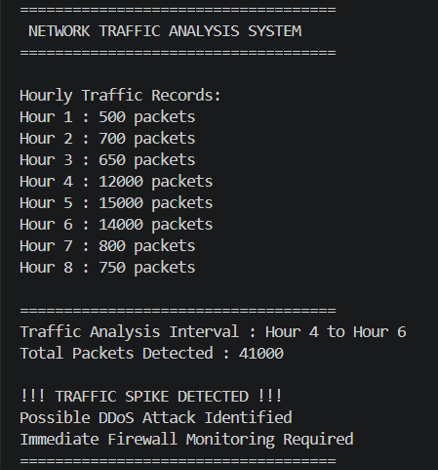
The network traffic monitoring system successfully analyzed packet traffic using Segment Tree operations.
The system efficiently detected abnormal traffic spikes, monitored packet flow across different time intervals, and identified possible DDoS attack patterns.
Segment Tree range query operations improved traffic analysis efficiency, making the framework suitable for scalable real-time cybersecurity traffic monitoring applications.
Time Complexity:
• Segment Tree Construction : O(n)
• Range Query Operation : O(log n)
• Traffic Spike Detection : O(log n)

GitHub Link: https://github.com/medipallysreeya-commits/Adaptive-Cyber-Threat-Indexing-Framework.git
Student Signature | Faculty Signature

